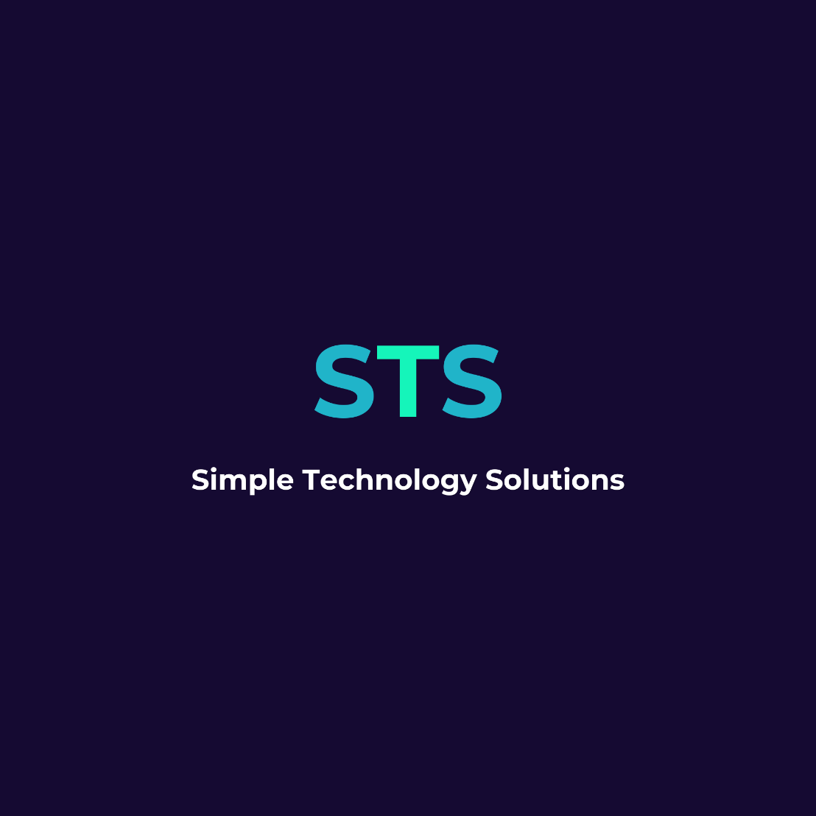

BRAND KIT

21 June 2026
BY KYLIE STEWART

Table of Contents

Table of Contents 2
Document Information 3
Purpose 3
Version Control 3
Introduction 4
Brand Foundation 5
Messaging Framework 6
Website Messaging 7
Taglines 8
Logo 9
Textures & Backgrounds 11
Colour Palette 12
Typography 13

Document Information

Purpose
This document defines how Simple Technology Solutions communicates its value across all external channels. It ensures consistent messaging as the business scales, so all teams, partners, and contributors express the brand clearly and consistently.
It exists to:
- Reduce ambiguity in communication
- Prevent message drift
- Ensure consistent representation across all touchpoints
- Support clear, confident articulation of value

Version Control
VERSION | PURPOSE | DISTRIBUTED
0.01 | Draft | Internal
1.0 | FINAL | Directors

Introduction
This Brand Kit defines how Simple Technology Solutions (STS) should be expressed visually and verbally. It sets out tone, structure, and design principles to ensure the brand is clear, consistent, and recognisable across all platforms.
It is designed for practical use across documents, presentations, marketing, digital platforms, and client communications.

Brand Foundation
Brand Foundation defines the core identity of STS, including purpose, positioning, messaging, and value. It sets the strategic direction for how the brand should be understood and communicated across all environments.
It is designed to ensure that there is a clear and consistent definition of what the business does, who it serves, and the value it delivers, so that all communication remains aligned and intentional.
TAGLINE
Make Work Simple
ELEVATOR PITCH
We help businesses save between $X and $Y per year by automating everyday operations and making work simple.
VALUE PROPOSITION
Simple Technology Solutions is a platform that helps businesses save time and reduce costs by making work simple through automation of everyday operations. It turns inefficient workflows into streamlined processes that improve productivity, reduce manual work, lower operational overhead, and enable businesses to scale without increasing workload. Our focus is improving how businesses operate through practical automation that delivers measurable results.
BRAND POSITIONING
Simple Technology Solutions is a platform that helps small to medium businesses make work simple by automating everyday operations and turning inefficient workflows into streamlined processes that improve productivity and reduce operational overhead.
BRAND PURPOSE
To make work simple by removing operational complexity through automation of everyday business processes.
MISSION STATEMENT
To help businesses achieve measurable time and cost savings by automating everyday operations and improving how work gets done.
BRAND PROMISE
We help businesses reduce operational complexity and improve efficiency through automation of everyday work.

Messaging Framework
The Messaging Framework defines how STS communicates its value in a clear and consistent way. It brings together the core messages, benefits, and communication pillars that should be used across all external content.
It is designed to ensure that all messaging is simple, aligned, and outcome-focused, so that the value of the business is consistently understood regardless of channel or audience.
CORE MESSAGE
Make work simple through automation that reduces manual effort, improves productivity, lowers costs, and enables businesses to scale without increasing workload.
CUSTOMER BENEFITS
Reduce manual and repetitive work |  |  | Improve operational efficiency |  | Save time across teams
Lower operational costs |  |  | Increase productivity |  | Recue operational overhead
Scale without increasing workload |  |  | Simplify everyday workflows
KEY MESSAGING PILLARS
Simplicity |  | work should be easier, not harder
Cost Reduction |  | remove inefficiencies
Productivity |  | achieve more with less effort
Automation |  | replace repetitive manual work and remove human error
Scalability |  | grow without increasing workload
BRAND PERSONALITY
Practical |  |  | Clear |  | Outcome driven
Reliable |  |  | Straightforward |  | Modern
BRAND VOICE
We sound like
Clear and direct | Human and practical |  |  | Outcome focused |  | Simple Language
We do NOT sound like:
Buzzword heavy | Overly technical |  |  | Corporate jargon |  | Abstract or vague

Website Messaging
Website Messaging defines how the brand is communicated in digital environments, particularly on the website. It sets out the key messaging structure, including headlines, supporting copy, and calls to action.
It is designed to ensure that visitors immediately understand what the business does, the value it provides, and the actions they should take, in a clear and simple way.
HERO HEADLINE
Make Work Simple
SUBHEADING
We help businesses reduce costs and improve productivity by automating everyday operations and simplifying how work gets done.
CALL TO ACTION
Make work simple – start free

Taglines
Taglines define the short-form expressions of the brand used for recognition, recall, and reinforcement of key messaging. They are designed to capture the essence of the brand in simple, memorable language.
They ensure that the brand can be consistently represented in short-form contexts such as marketing materials, social content, and visual assets, without losing clarity or meaning.
PRIMARY
Make Work Simple
SUPPORTING THEMES
Workflow simplification |  | Cost reducing through automation |  | Operational improvement
Productivity gains |  | Before Vs after process improvements |  | Business efficiency wins
Practical |  | High clarity |  | Productive
CANVA KEYWORDS
Modern | Minimal |  | Clean |  | Professional
Efficient | Smart |  | Business-focused |  | Streamlined
Practical | High clarity |  | Productive |  | Simple

Logo
The Logo section defines how the STS visual identity is applied across different formats and contexts. It includes the primary logo, secondary logo, icon usage, and layout rules.
It is designed to ensure the brand is always represented consistently, clearly, and professionally across all applications, regardless of size, format, or platform.
PRIMARY LOGO
Used across all major applications:  - Website  - Proposals  - Marketing materials  - Presentations | 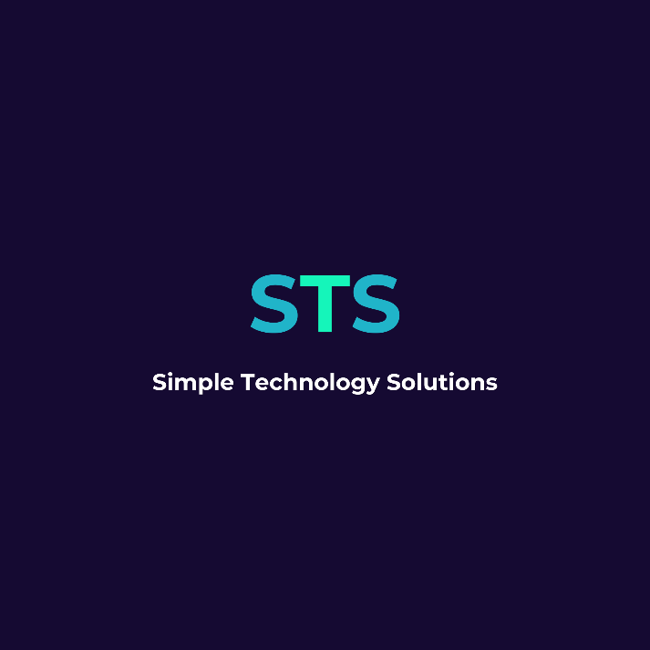
SECONDARY LOGO
Used where horizontal space is limited:  - Social media headers  - Profile images  - Narrow layouts | 
ICON
Used for:  - Favicons  - App icons  - Watermarks | 
WORDMARK
Used where the full brand name needs to be clearly presented in vertical format. This includes:  - Website headers and hero sections (stacked layouts)  - Presentation title slides  - Formal documents and proposals  - Marketing materials where vertical space is preferred over horizontal layout | 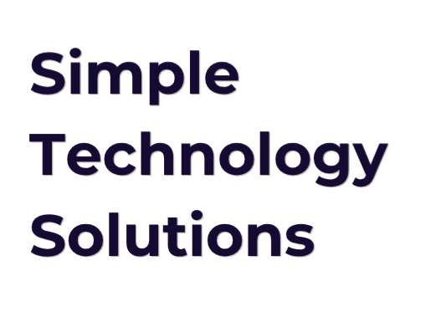
LAYOUT RULES
Maintain strict hierarchy:
Primary Logo (largest)
↓
Secondary Logo (medium)
↓
Icon (smallest)
Do not scale elements arbitrarily. Consistency is essential to brand recognition.
LOGO USAGE RULES
Always maintain clear space around the logo (minimum equal to height of one “S”) | Do not stretch, distort, or rotate
Do not change colours outside approved palette | Do not place on busy or low-contrast backgrounds
Prefer Midnight Indigo backgrounds or white space for clarity
LOGO COLOUR APPLICATION
STS Monogram  S — Digital Teal #20B4C9  T — Electric Mint #15F5BA  S — Digital Teal #20B4C9  Background — Midnight Indigo #150A32 | Full Brand Name Lockup  Text: White #FFFFFF  Typeface: Montserrat Bold  Background: Midnight Indigo #150A32

Textures & Backgrounds
STS has incorporated a background visual treatment to support and add depth and consistency across all brand design materials. This treatment is based on a controlled abstract texture inspired by digital infrastructure and system networks, reflecting the underlying processes that enable automation and simplify complex operations.
It is used as a supporting visual layer rather than a primary design element, ensuring that content, messaging, and readability remain the priority. The purpose of this treatment is to create a consistent visual environment across presentations, documents, and digital materials, so that all brand outputs feel connected, structured, and recognisably part of the STS system.
BACKGROUND
Used to create visual depth and support the brand imagery such as:  - Website hero backgrounds (light or softened version)  - Presentation slides and pitch decks  - Brochures and marketing documents  - Section dividers in longer documents  - Background layering in branded visuals | 
USAGE RULES
Used as a background layer only | Must always remain secondary to text and key messaging
Text must remain fully readable over all applications | Indigo must remain the dominant visual tone
Teal is used sparingly as a supporting accent
DO NOT USE
Replacing logo or brand mark | Competing with key messaging or headlines
High-detail foreground visuals | Mixed, unfiltered stock imagery overlays

Colour Palette
The Colour Palette defines the official brand colours used across all visual materials. It establishes the role of each colour and how they should be applied in design and communication.
It is designed to ensure visual consistency, reinforce brand recognition, and maintain a clear and professional identity across all touchpoints.
BRAND COLOURS
Primary | Midnight Indigo |  |  | #150a32
Secondary | Digital teal |  |  | #20b4c9
Accent | Electric mint |  |  | #15f5ba
Neutral | White |  |  | #ffffff
COLOUR MEANING
Our colour palette is built to balance trust, clarity, and energy within a modern technology-focused identity. It is designed to feel grounded and professional at its core, while still allowing space for bold, high-impact accents that communicate innovation and momentum.
Midnight Indigo |  | serves as the primary brand colour, forming the foundation of the identity. It represents stability, depth, and reliability — reinforcing trust in the solutions we provide.
Digital Teal |  | is the secondary colour, supporting the primary palette with a sense of clarity, intelligence, and approachability. It is used to add structure and variation across layouts while maintaining a consistent brand feel.
Electric Mint |  | is the accent colour, used sparingly to draw attention to key actions, highlights, and moments of emphasis. It represents energy, efficiency, and transformation.
White |  | acts as the neutral base and default background colour, ensuring simplicity, readability, and strong contrast across all brand materials.
USAGE RULES
Midnight Indigo |  | leads all core branding elements (logos, headers, key identity areas)
Digital Teal |  | supports structure, sections, and secondary emphasis
Electric Mint |  | is reserved for calls-to-action (CTAS), highlights, and key points of focus
White |  | is the default background to maintain clarity and simplicity White is the default background for clarity and simplicity

Typography
Typography plays a key role in creating a consistent and professional brand experience. The STS typography system has been selected to balance a modern technology-focused identity with strong readability across digital, print, and presentation materials.
It is designed to ensure that all communication feels clear, structured, and easy to read, while still maintaining a strong and recognisable brand presence.
PRIMARY TYPEFACE
Montserrat |  |  | Montserrat is the primary typeface for the Simple Technology Solutions brand. It is used for the logo, headings, and key messaging.  Its clean, geometric style reflects the brand’s focus on simplicity, modern technology, and structured thinking.  Montserrat is used when we want to create impact, hierarchy, and strong visual identity.
Recommended Usage |  |  | Logo: Montserrat Bold  Main Headings (H1): Montserrat Bold  Section Headings (H2): Montserrat Bold  Sub-headings (H3): Montserrat Medium  Key Statements / Emphasis Text: Montserrat Bold (as needed for clarity and emphasis)
SECONDARY TYPEFACE
Calibri |  |  | Calibri is the supporting typeface used for body text and longer-form content.  It has been selected for its high readability, especially in digital environments, while still complementing the modern and structured feel of Montserrat.  Calibri is used when clarity and ease of reading are the priority.
Recommended Usage |  |  | Body Text: Calibri Regular  Captions / Notes: Calibri Regular  Supporting Content (documents, reports, proposals): Calibri Regular  Forms / Instructions / Explanatory Content: Calibri Regular
TYPOGRAPHY HIERARCHY
This hierarchy ensures consistent structure across all documents and materials.
Element | Typeface | Weight |  | Size | Spacing
Logo | Montserrat | Bold |  | As per logo system (STS lockup rules) | As per logo system (no paragraph spacing rules apply)
H1 Heading | Montserrat Black | Bold |  | 36–44pt | 18pt above / 6pt below  starts on new page  acts as section divider
H2 Heading | Montserrat | Bold |  | 24–30pt | 12pt above / 6pt below
H3 Heading | Montserrat | Medium |  | 18–22pt | 6pt above / 6pt below
Body Text | Calibri | Regular |  | 11-12pt | 6pt above / 6pt below
Captions / Notes | Calibri | Regular |  | 11-12pt | 6pt above / 6pt below
TYPOGRAPHY SIZE RULES
- Sizes are designed for Canva, Word, and presentation use
- Use the lower end of the range for dense documents
- Use the higher end of the range for presentations and marketing material
- Do not create additional heading levels outside this system
- Do not manually scale text outside these defined ranges
TYPOGRAPHY PRINCIPLES
- Use Montserrat for structure and emphasis (headings, branding, key messages)
- Use Open Sans for readability and explanation (anything longer or instructional)
- Avoid introducing additional fonts unless there is a clear and approved business need
- Maintain consistent font usage across Canva, Microsoft Office, website content, and all external communications
- Prioritise clarity over styling — if something becomes harder to read, simplify it

